**Misconceptie over Moslims**

Landen overschatten de grootte van de moslimpopulatie in hun land. Zoals te zien in de onderstaande grafiek denken Duitsers dat de moslimpopulatie 3.2x groter is dan deze daadwerkelijk is. Hongaren schatten deze zelfs 70x groter.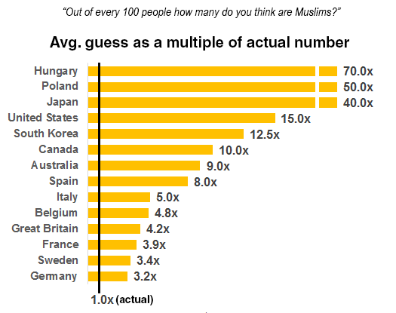

**Aantal Asiel aanvragen 2014**  
Misschien interessant om te schetsen welke landen de meeste asielzoekers krijgen binnen de EU. Nederland staat hierbij relatief laag. misschien ook een interessante relativering voor veel mensen. Wel belangrijk dat dit alleen over 2014 gaat (maar lijkt me alsnog goed voor een algemeen beeld).

|  |  |  |
| --- | --- | --- |
| Land | Aantal | Aantal per 1.000 inwoners |
| Duitsland | 662.680 | 8.07 |
| Oostenrijk | 34.580 | 3,97 |
| Malta | 1.390 | 3,20 |
| Griekenland | 30.495 | 2,83 |
| Hongarije | 26.875 | 2,73 |
| Luxemburg | 1.490 | 2,59 |
| Cyprus | 1.920 | 2,26 |
| Zweden | 22.295 | 2,26 |
| Bulgarije | 14.280 | 2,00 |
| Italië | 85.050 | 1,40 |
| België | 13.680 | 1,21 |
| Frankrijk | 61.830 | 0,93 |
| Denemarken | 5.290 | 0,93 |
| Nederland | 14.775 | 0,87 |
| Finland | 4.665 | 0,85 |
| Totaal Europese Unie-28 | 1.038.810 | 2,04 |

Tabel bron: Min. VenJ, Rapportage Vreemdelingenketen, o.b.v. Eurostat, 2015

**Afkomst van Asielzoekers EU 2014**  
Tabel die afkomst van asielzoekers in EU weergeeft.

|  |  |  |
| --- | --- | --- |
| **Land van herkomst** | **aantal** | **percentage** |
| Syrië | 14.663 | 40% |
| Eritrea | 3.712 | 10% |
| Stateloos | 2.137 | 6% |
| Marokko | 1.724 | 5% |
| Algerije | 1.371 | 4% |
| Irak | 1.214 | 3% |
| Afghanistan | 949 | 3% |
| Onbekend | 925 | 3% |
| Iran | 835 | 2% |
| Albanië | 634 | 2% |
| Anders | 8.461 | 23% |
| Totaal | 36.625 | 100% |

Tabel: personen in opvang, naar nationaliteit, (Bron: IND (aug. 2015) Asylum trends)

**Hier staan ook wat mogelijk interessante statistieken:** <http://www.bbc.com/news/world-europe-34131911>

**Verklaring Pieken en Dalen in Grafiek**

*Piek Italie 2014 (https://en.wikipedia.org/wiki/European_migrant_crisis):*

In 2008, [Berlusconi](https://en.wikipedia.org/wiki/Silvio_Berlusconi)'s government in Italy and [Gaddafi](https://en.wikipedia.org/wiki/Muammar_Gaddafi)'s government in Libya signed a treaty including cooperation between the two countries in stopping irregular migration from Libya to Italy; this led to a policy of forcibly returning to Libya boat migrants intercepted by the Italian coast guard at sea.The cooperation collapsed following the outbreak of the [Libyan civil war](https://en.wikipedia.org/wiki/Libyan_Civil_War_(2011)) in 2011, and in 2012 the [European Court of Human Rights](https://en.wikipedia.org/wiki/European_Court_of_Human_Rights) ruled that Italy had violated the [European Convention on Human Rights](https://en.wikipedia.org/wiki/European_Convention_on_Human_Rights) by returning migrants to Libya, as it exposed the migrants to the risk of being subjected to [ill-treatment](https://en.wikipedia.org/wiki/European_Convention_on_Human_Rights#Article_3_-_torture) in Libya and violated the prohibition of [collective expulsions](https://en.wikipedia.org/wiki/European_Convention_on_Human_Rights#Protocol_4_-_civil_imprisonment,_free_movement,_expulsion).

Since 2011, and particularly since 2014, instability and the [Second Civil War in Libya](https://en.wikipedia.org/wiki/Libyan_Civil_War_(2014%E2%80%93present)) have made departures from the north-African country to Italy easier, with no central authority controlling Libya's ports and dealing with European countries, and [migrant smuggling](https://en.wikipedia.org/wiki/Migrant_smuggling) networks flourishing. The war could also have forced to leave many African immigrants residing in Libya, which used to be itself a destination country for migrants looking for better jobs. The [2013 Lampedusa migrant shipwreck](https://en.wikipedia.org/wiki/2013_Lampedusa_migrant_shipwreck) involved "more than 360" deaths, leading the Italian government to establish [Operation Mare Nostrum](https://en.wikipedia.org/wiki/Operation_Mare_Nostrum), a large-scale naval operation that involved [search and rescue](https://en.wikipedia.org/wiki/Search_and_rescue), with some migrants brought aboard a naval [amphibious assault ship](https://en.wikipedia.org/wiki/Amphibious_assault_ship).

*Eerst Hoge aantallen in Spanje, daarna negatief (http://bruegel.org/2015/12/the-remarkable-case-of-spanish-immigration/):*

Between 2002 and 2014, Spain received an accumulated immigration inflow of 7.3 million and a net flow of 4.1 million, making it the second-largest recipient of immigrants in absolute terms among OECD countries, following the United States.

This migration episode was largely concentrated during the first decade of the century, peaking in 2007. After the financial crisis the number of foreigners leaving Spain rapidly increased, while inflows became weaker, leading to much lower net flows (becoming modestly negative between 2012 and 2014).